Re-Final Exam
Total Time (Hrs): | 3
Total Marks: | 100
Total Questions: | 3
Fundamentals of Software Project Management (SE4002)
Date: Jan,5, 2024
Course Instructor(s)
Dr.Syed Muazzam Ali Shah and Mr.Minhal Raza

Roll No Section Student Signature
Do not write below this line

Attempt all the questions.

CLO #2: Critically evaluate and discuss the issues around project management and its application in the real world

Q1 : Read and comprehend the following case study and answer the questions at the end of the case study in 3 to 5 lines /points only. [20 Points, Est Time : 25 Mintues]

- Alex is a project manager overseeing the development of a mobile app for high school chemistry students. The project has a six-month deadline and a tight budget. The team is spread across different locations, which creates communication challenges. Alex has to manage remote meetings, ensure that tasks are completed on time, and adjust the schedule as new features are requested by the marketing team. Along the way, some team members have conflicts over unclear roles, and technical issues arise with the integration of interactive quizzes into the app. Despite these hurdles, Alex stays organized, makes sure resources are used efficiently, and maintains strong relationships with both the development team and external stakeholders. Alex also stays calm under pressure and quickly adapts to unexpected changes, ensuring the project moves forward. Identify the project management skills Alex demonstrated in the case study,Explain how these skills contributed to managing the challenges and ensuring the project's success .[5 Points]

communication skills, time management, conflict resolution, adaptability, and stakeholder management.

- A local school is developing a School Management System (SMS) to streamline administrative tasks like student registration, attendance tracking, and exam scheduling. The primary users will be teachers and administrative staff, while students and parents will use it voluntarily for checking attendance, grades, and notifications. The project manager, Sarah, emphasizes the focus on improving administrative efficiency, but some stakeholders suggest prioritizing features for students and parents, such as personalized dashboards. Sarah asks the team to categorize the project to clarify its purpose and align resources effectively. The team debates whether to classify the project based on compulsory vs. voluntary users, information system vs. embedded system, or objectives vs. products to better define their approach.Based on the details provided, identify one way of categorizing the project and explain why your choice is the most relevant for this project. Justify your answer with examples from the scenario. [5 Points]

Compulsory Vs Voluntary Users and Objective vs Products

- A tech company is working on developing an online learning platform designed to offer courses in various subjects, including programming, data science, and digital marketing. The platform is intended to be intuitive for students, allowing them to access courses, track progress, and engage in community discussions. The project team has already outlined the scope and cost but now, they plan to ensure the platform is bug-free and user-friendly, conduct regular meetings with instructors to align course content, and Based on the scenario, identify which knowledge areas, except for scope and cost management, should be needed and applied in this project. Explain why each area is relevant to manage potential risks such as platform downtime or user data privacy and quality concerns.[5 Points]

Quality Management, Risk Management, Communication Management, Stakeholder Management, and Integration Management.

- Mo is a systems analyst who is gathering requirements for an application which will record detail of the training undertaken by fire-fighters in the client fire brigade. Details of the training unit successfully completed by fire-fighters are to be input to the application by trainers who arc themselves sensor and active fire-fighters. Mo needs to interview a trainer to obtain his/her requirement.. Because of the senior fire-fighters' other duties the interview has to be arranged two weeks in advance. There is then a 20% chance of the fire-fighter being unable to attend the interview because of an emergency call-out . Each week that the project is delayed costs the fire brigade approximately $1000. Provide an estimate of the risk exposure (as a financial value) for the risk that the senior fire-fighter might not be able to attend at the times needed and suggest possible risk mitigation actions. [5 Points]

Risk value = $1000*20% = $200, Schedule Backup Interviews,Document and Analyze Existing Data, and Engage Secondary Stakeholders

CLO #3: Choose project management techniques for IT projects to initiate, plan, execute and evaluate a project and work in teams to create a project plan for a project scenario that includes key tasks, critical path, dependencies and a realistic timeline.

Q2 : Solve the following question [60 Points, Est Time : 120 Minutes]

A. Given the information in the following lag exercises, compute the early, late, and slack times for the project network. Which activities on the critical path have only the start or finish of the activity on the critical path? [7.5 Points]


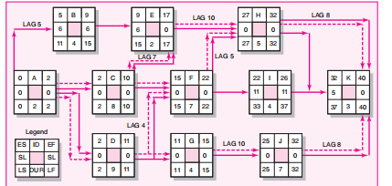

B. You have prepared the following schedule for a project in which the key resources is a tractor. There are maximum three tractors available to the project. Activities A and D require one tractor to complete while activities B, C, E and F require 2 tractors. Develop a resource-constrained schedule (including network diagram,resource histogram and gantt-chart) in the loading chart that follows. Be sure to update each period as the computer would do. Record the early start (ES), late finish (LF) and slack (SL) for the new schedule. [7.5 Points]
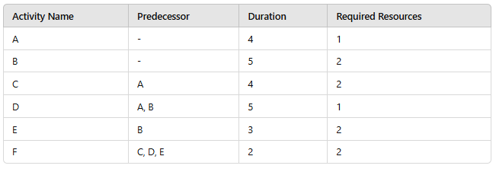

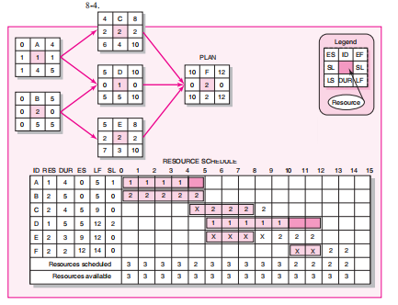

C. Buy Right. a software house, is considering developing a payroll application for use in academic institution and is currently engaged in a cost-benefit analysis. Study of the market has shown that, Buy Right can target it efficiently and no competing products become available. it will obtain a high level of sales generating an annual income of £800,000. It estimates that there is a 1 in 10 chances of this happening. However, a competitor might launch a competing application before its own launch date and then sales might generate only £100,000 per year. It estimates that there is a 30% chance of this happening. The most likely outcome, it believes, is somewhere in between these two extremes - will gain a market lead by launching before any competing product becomes available and achieve an annual income of £650,000. [5 Points]
- Calculate Buy right expected sales income? [2.5 Points]


- Development costs are estimated at £750,000. Sales levels are expected to be constant for at least four years. Annual costs of marketing and product maintenance arc estimated at £200,000. irrespective of the market share. Would you advise going ahead with the project? [2.5 Points]
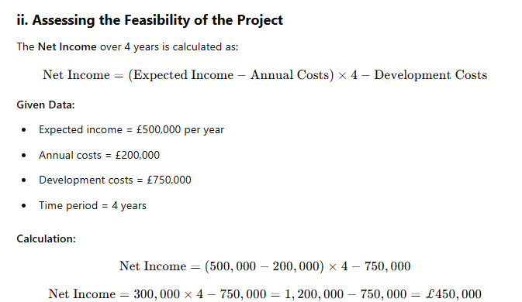

Answer: The project yields a net income of £450,000 over four years. Therefore, the project is advisable to proceed

D. A company is evaluating three potential projects based on their expected cash flows over the next 5 years. The table below shows the expected annual cash inflows and outflows for each project. Some of the projects have negative cash flows in later years due to unexpected costs. The company wants to select the most profitable project based on the following financial metrics: Payback Period, Net Present Value (NPV), Return on Investment (ROI), and Internal Rate of Return (IRR). [10 Points]
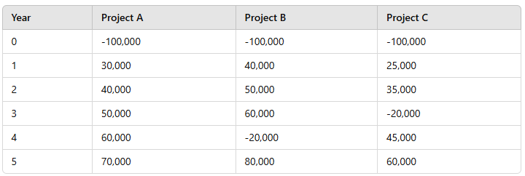

- Based on the cash flow table, comment on the trends of inflows and outflows for each project. Which project has the most variation in cash flows, and which project seems to generate the highest cash inflows in later years?[3 Points]

Project A shows consistent growth in cash inflows over the years. Project B has high inflows initially but includes a significant outflow in Year 4, indicating variation. Project C has inconsistent inflows, including a negative value in Year 3. Project B shows the most variation in cash flows, while Project B generates the highest inflows in later years (Year 5).

- Calculate the payback period and ROI for each project and comment.[2 Points]
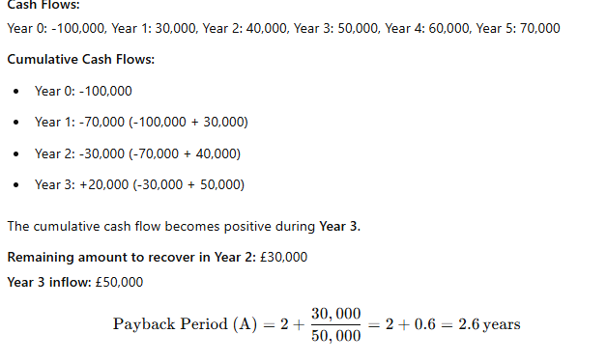
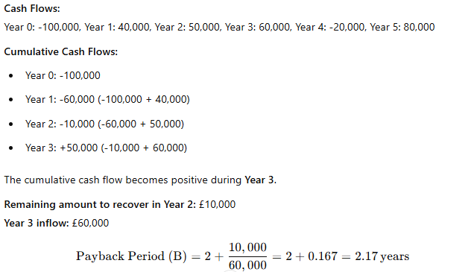

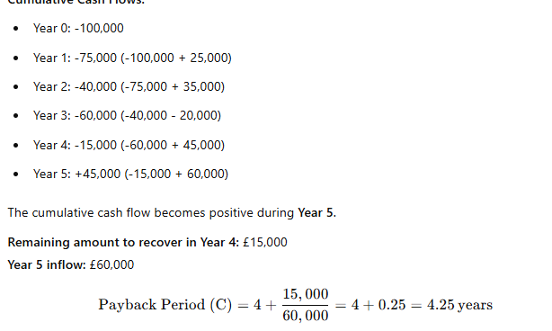

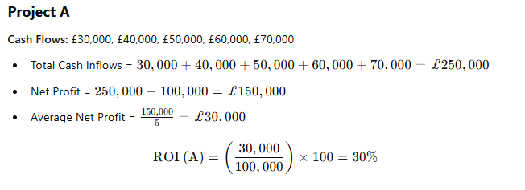
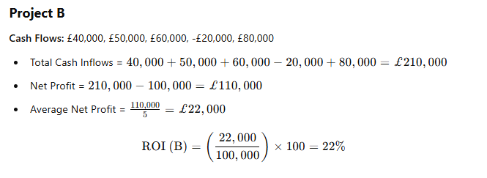
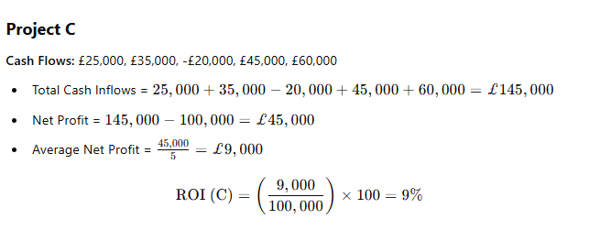
- Using a discount rate of 8%, 10%, and 12%, calculate the NPV for each project and comment which project will going to be select and why?[2 Points]

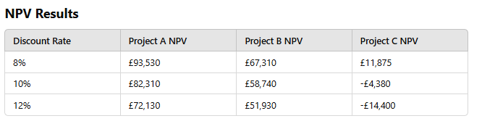
• Project A has the highest NPV across all discount rates, making it the most financially viable project.
• Project B is the second-best option, but it generates a lower NPV.
• Project C has a positive NPV only at an 8% discount rate and turns negative at higher rates, indicating a higher risk.
Recommendation: Select Project A as it provides the best return on investment with the highest NPV.

- Calculate the IRR for Project C under the discount rate range of 17% to 20%.[2 Points]

Some where around 18 point something

E. The network and duration’s given in the following figure shows the normal schedule for a project. You can crash (decrease) the duration's at an additional cost. The Table given below summarizes the time-cost information for the activities. The owner wants you to complete the project in 110 days. Find the minimum possible cost for the project if you want to complete it in 110 days. Cost is given in dollars ($) and time duration in days. Note : “Short hand method’s for solving this numerical are not allowed . You have to show each and every steps with proper calculation which are discussed in classes”. [10 Points]

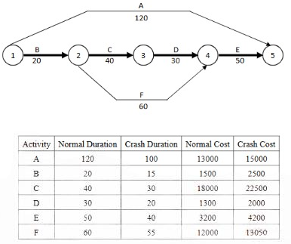

Answer : Refer to the word document crashing example

F. A project consists of the following 5 activities, and the duration's are given as optimistic (O), most likely (M), and pessimistic (P) estimates. Use the PERT method to calculate the expected time (TE), variance (V), and then answer questions about the probability of completing the project in a given time. [10 Points]

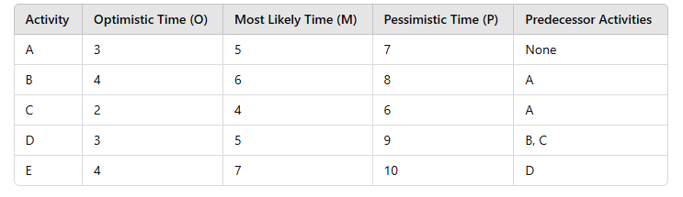

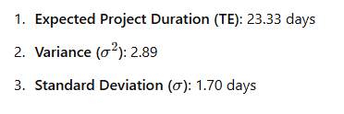
- What target time corresponds to the 80% probability of completing the project? [3 Points]
The target time corresponding to an 80% probability of completing the project is approximately 24.76 days.
- What is the probability of completing the project between 25 days “and” 30 days? [3 Points]
0.163 (approximately 16.34%).
- If a specific activity is delayed by a known number of days (e.g., Activity B is delayed by 3 days), how does this impact the overall probability of completing the project within a given time frame? [4 Points].
The probability will decrease.

G. A software company is considering two options for maintaining their software system over the next 3 years. The company needs to decide between Option A: In-house maintenance and Option B: Outsourcing maintenance. Both options come with varying costs, risks, and probabilities of success. The company is trying to make a decision on which option will provide the best return on investment (ROI) and minimize the associated risks.

Option A: In-house Maintenance Year 1: The initial cost of setting up an in-house team is $150,000. The team will maintain the system for the first year with an expected success rate of 80%. If successful, the maintenance cost will be $50,000 per year for the next two years. However, if the maintenance fails (20% chance), the company will need to spend an additional $100,000 for repairs, and the maintenance costs will increase to $75,000 for the remaining two years. Option B: Outsourcing Maintenance Year 1: The cost of outsourcing the maintenance is $120,000. If the outsourcing is successful (70% probability), the company will incur a cost of $60,000 each year for the next two years. If the outsourcing fails (30% probability), the cost will increase to $90,000 per year for the next two years, along with an additional $50,000 in penalty charges for failure.

Construct a Decision Tree for both options (In-house and Outsourcing) based on the information provided. Show all branches, costs, and probabilities.Calculate the Expected Monetary Value (EMV) for both Option A (In-house) and Option B (Outsourcing) over the 3 years. Based on the EMVs, which option is the more financially viable choice?[10 Points]
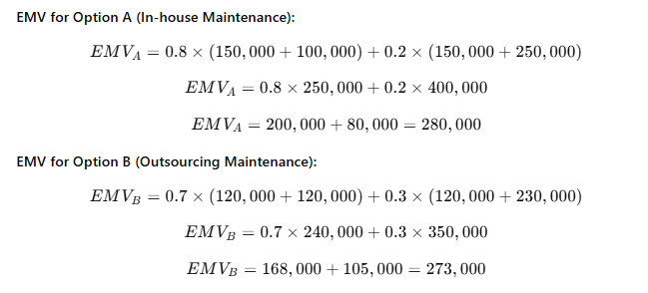

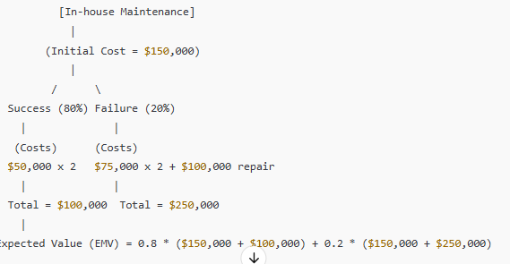

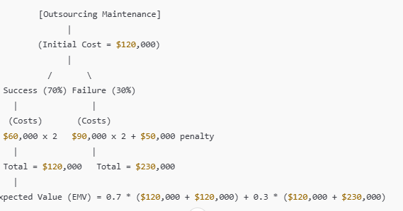

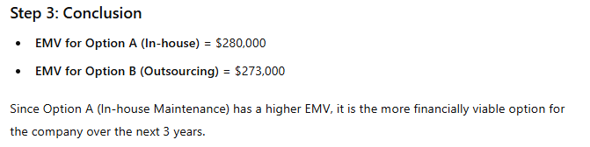

CLO #4: Present strategies for gaining confidence in managing projects through simple project planning examples.

Q3 : Shortly answers the following questions in to 3 to 4 lines/points only. [20 Points, Est Time : 20 Mintues]

What are the key differences between the feasibility study and a business case.Why we create them?
Feasibility Study: Focuses on determining whether the project is technically, legally, and financially possible. It assesses if the project can be realistically completed with available resources.
·Business Case: A detailed justification for the project, outlining the benefits, costs, risks, and alignment with organizational goals. It helps in making decisions about whether to proceed with the project.

Why there is a need of Project Management Tools . What are the limitations of Tools? Explain your answer with the help of “MS-Project” example. [4 Points]

Project management tools help in planning, scheduling, and tracking project progress. They ensure efficient resource allocation and better communication. However, MS-Project, like other tools, may face limitations such as complexity in use, high learning curve, and dependency on accurate input data, which can lead to inefficiencies if not handled properly.

- Write the step by step procedure for creating network diagram in “MS-Project”. [4 Points]

Step-by-Step Procedure for Creating a Network Diagram in MS-Project:

Open MS-Project: Launch MS-Project and create a new project file.
Enter Tasks: Input all tasks in the "Gantt Chart" view. Ensure the task names, durations, and dependencies are defined.
Define Dependencies: For each task, establish dependencies by linking tasks using the "Predecessor" column.
Switch to Network Diagram View: Go to the "View" tab and select "Network Diagram" from the available views.
Adjust Layout: The tasks will appear as nodes with arrows showing dependencies. You can customize the layout to enhance readability.
The Network Diagram provides a visual representation of task sequences, helping identify project flow and critical paths.

- Compare Time Management vs Risk Management , Resource Leveling vs Resource Smoothing , and Programme vs Portfolio Management. [4 Points]
Time Management vs Risk Management:

Time Management focuses on planning, scheduling, and controlling time to ensure project tasks are completed on time. It includes techniques like setting deadlines and managing milestones.
Risk Management identifies, assesses, and mitigates potential risks that could impact the project. It involves proactive planning for risks to minimize their negative effects.

Resource Leveling vs Resource Smoothing:

Resource Leveling aims to balance resource allocation, avoiding overuse or underuse by adjusting task schedules. It may extend the project duration.
Resource Smoothing adjusts the task schedule to maintain a steady resource usage level without extending the project timeline, typically within resource limits.

Programme vs Portfolio Management:

Programme Management focuses on managing a group of related projects to achieve strategic objectives and benefits.
Portfolio Management oversees a collection of projects and programmes, ensuring they align with organizational goals and priorities for maximum value.

- Explain the ways of assessing any project with examples. Compare the Economic assessment metrics in terms of pros and cons. [4 Points]

Cost-Benefit Analysis: Compares the expected benefits with the costs to determine if the project is worth pursuing (e.g., a new software development project vs. its development and maintenance costs).

Risk Analysis: Assesses potential risks and their impacts on the project’s success (e.g., a construction project considering weather and material delays).

Economic Assessment Metrics:

Net Present Value (NPV): Measures the project's profitability by comparing the present value of inflows and outflows.

Pros: Provides a clear financial view of project value.
Cons: Sensitive to discount rate assumptions.
Internal Rate of Return (IRR): Determines the rate at which NPV becomes zero, helping assess project profitability.

Pros: Easy to interpret and widely used.
Cons: Can be misleading for non-conventional cash flows or mutually exclusive projects.
Payback Period: Calculates how quickly initial investment is recovered.

Pros: Simple and easy to understand.
Cons: Ignores time value of money and cash flows after payback period.
These metrics help evaluate a project’s financial feasibility but have limitations based on assumptions and project characteristics.

Note : “Students can bring or use Z-table, Discount Rate Factor Table, and Formula Sheet for solving numericals. A scientific calculator is also allowed.”

